

**DEPARTMENT OF COMPUTER SCIENCE**

**AND APPLICATIONS**

**IBM PROJECT REPORT**

**HEALTH LINK**

An innovative Hospital management system

Submitted by

ANAMEKA .B (222312120)

PURVAJA .S (222312127)

BRINDHA .V (222312121)

**BACHELOR OF SCIENCE IN COMPUTER**

**SCIENCE WITH ARTIFICIAL INTELLIGENCE**

**Under the guidance of**

**Aiswarya Vijayan - Corporate Trainer**

**2023 – 2024**

**DECLARATION**

We, ANAMEKA .B, PURVAJA. S and BRINDHA .V of I BSC.CS WITH AI hereby declare that this project report on *“HEALTH LINK AN INNOVATIVE HOSPITAL MANAGEMENT SYSTEM”* data using by COGNOS Tool is submitted to University of Madras in partial fulfillment of the requirement for the award of the Degree of Bachelor of computer science with Artificial intelligence, under the guidance of DR. G. MONIKA M.SC (PHD) HEAD OF THE DEPARTMENT and SUBHA SRI .S has not been submitted earlier to any other university or institute for the award of any degree.

ANAMEKA .B

PURVAJA .S

BRINDHA .V

Place:

Date:

**BONAFIED CERTIFICATE**

This is to certify that the project titled “HEALTH LINK AN INNOVATIVE HOSPITAL MANAGEMENT SYSTEM” data using COGNOS Tool,sis the bonafide work done by ANAMEKA .B, PURVAJA .S and BRINDHA .V hereby and first year students of Jeppiaar College of Arts and Science, Padur, Chennai in partial fulfillment of the requirement for the award of the Degree of Bachelor of computer science with Artificial intelligence, during the academic year 2023-2024.

PROJECT GUIDE: SUBHA SRI .S

HEAD OF THE DEPARTMENT:

Date:

INDEX

|  |  |  |
| --- | --- | --- |
| S.NO | CONTENTS | PAGE NO: |
| 1. | INTRODUCTION |  |
| 2. | ABSTRACT |  |
| 3. | REPORTS  Patient Records  Hospital facilities  Staff details  Financial Information  Countries which are use IOT in healthcare |  |
| 4. | FINAL DASHBOARD |  |
| 5. | CONCLUSION |  |
| 6. | REFERENCES |  |

**INTRODUCTION:**

Our project focuses on leveraging IBM COGNOS Analytics for analysing hotel management data, with COGNOS versatile toolbox including List, Text, Item, Block, Table, Crosstab and Visualization features, we delve into data exploration and analysis. By uncovering trends and patterns, we aim to enhance operational efficiency and evaluate to deliver high-quality services while optimizing administrative tasks. Join us in revolutionizing healthcare management with HEALTH LINK. Join us we utilize COGNOS to extract actionable insights and drive informed decision-making in Healthcare management.

**ABSTRACT:**

This project explores the utilization of IBM COGNOS Analytics for analysing a Hospital management data, aiming to enhance to make informed decisions and optimized processes, ultimately leading a enhanced patient care and improved outcomes. It is including List, Text Item, Block, Table, Crosstab and Visualization features, we delve into data exploration and analysis. Through uncovering the New trend and patterns, actionable insights are extracted to make a informed decision making. Join us on this journey as we showcase the power of COGNOS in unlocking the potential for strategic decision-making and operational excellence in Healthcare management.

**REPORTS:**

1.Patient records: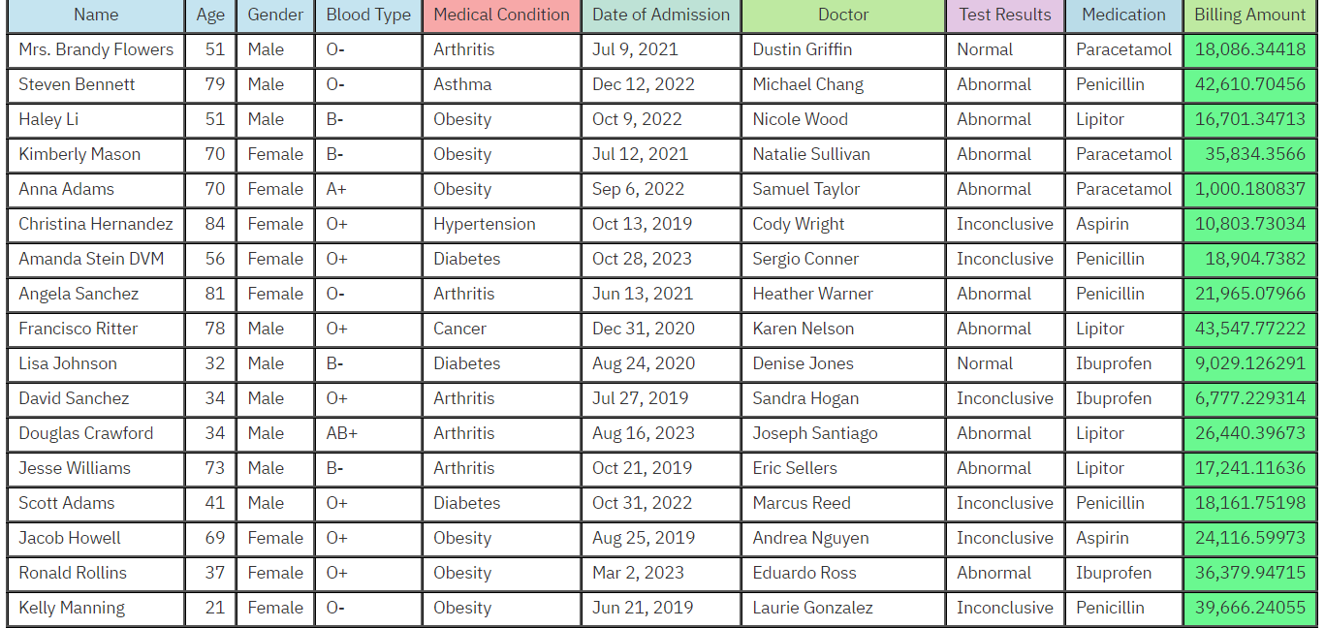

2. Hospital facilities:

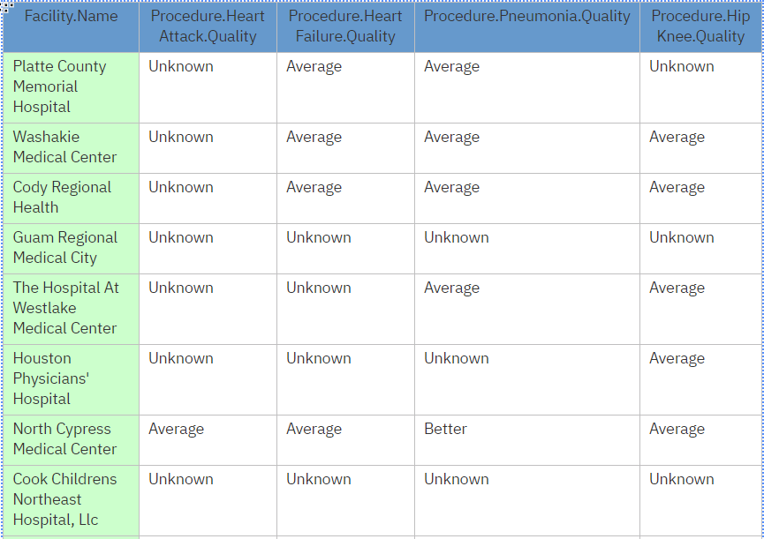

3. Staff Details:

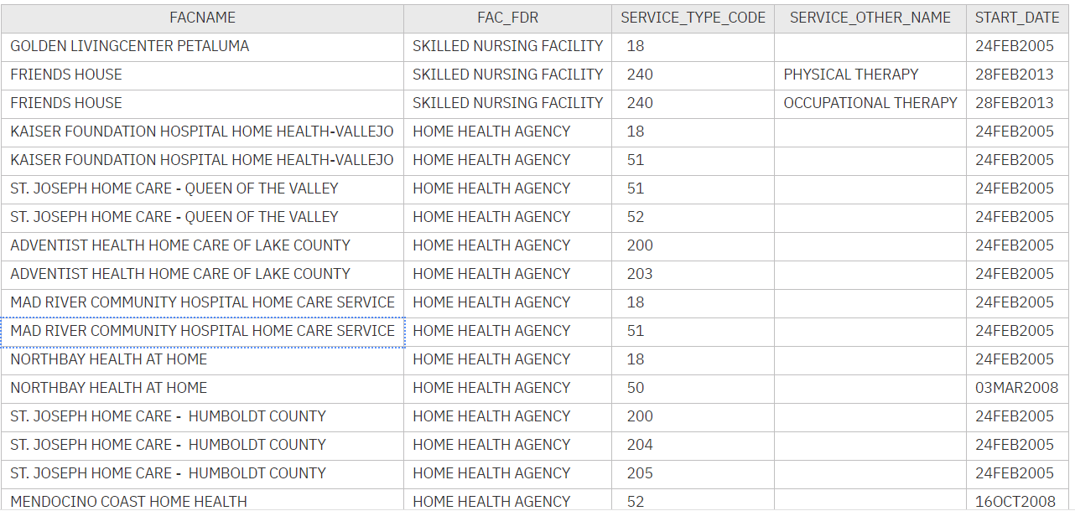

4. Financial information:

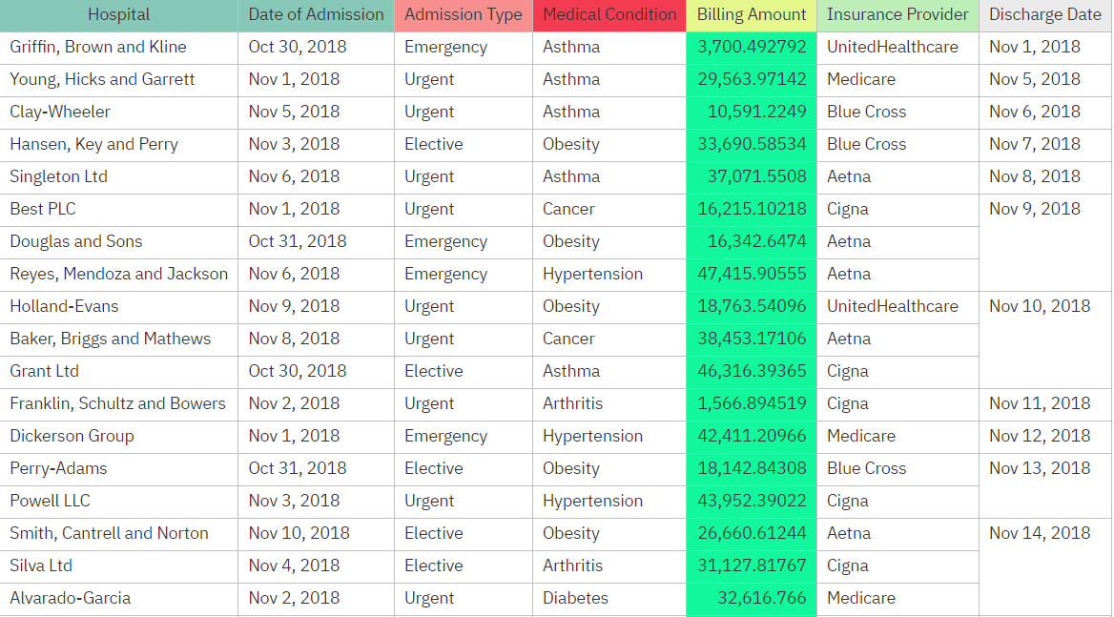

5. COUNTRIES WHICH ARE USE IOT IN HEALTHCARE:

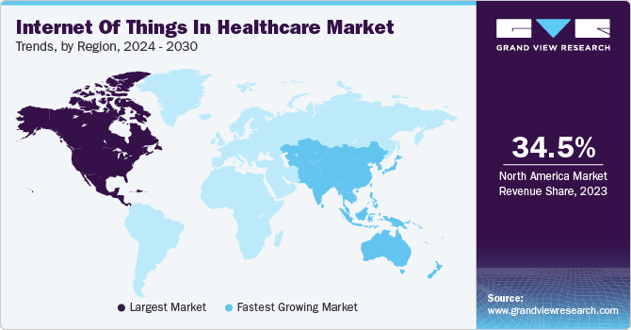

**FINAL DASHBOARD:**

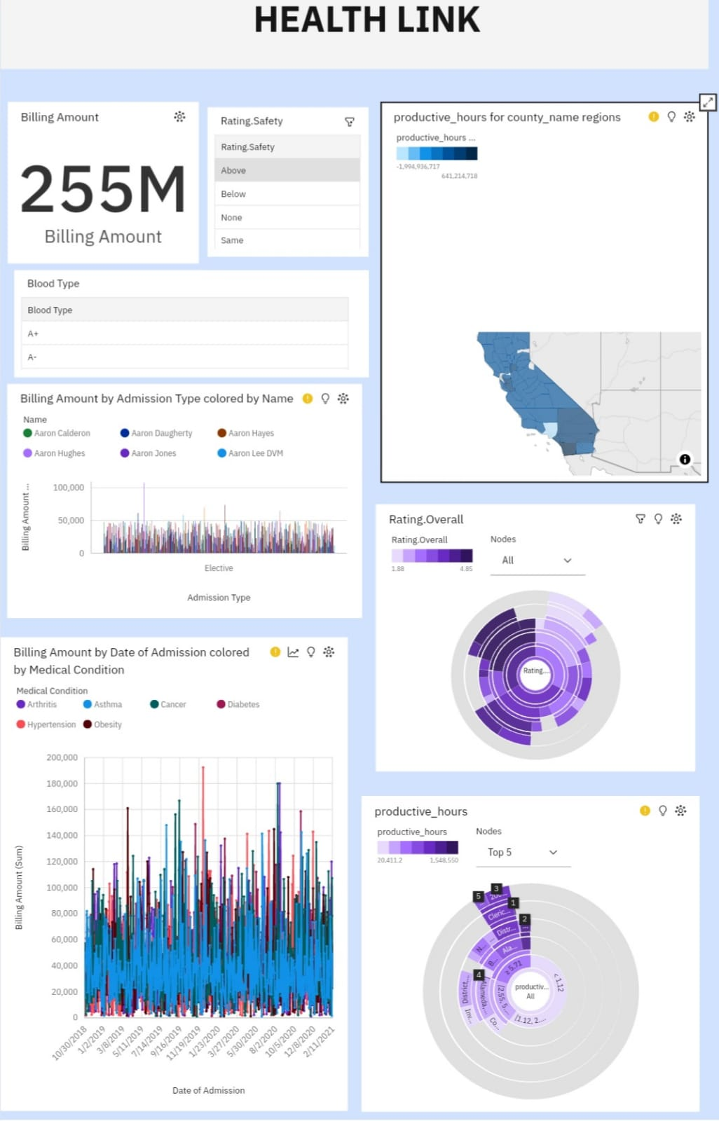

**CONCLUSION:**

Our project has used IBM COGNOS Analytics to study and do more efficiently in Healthcare management system. We were explored different parts of the data using tools like lists, tables, and visualization. By doing this, we’ve found trends and patterns that help hotels run more smoothly and make guests happier. This shows how important it is to use data to make smart decisions in the hotel industry.

Our work is just the beginning. We’ll keep using COGNOS Analytics to find even more ways to improve Hospitals and Healthcare management system in trending ways and it is designed to streamline healthcare operations and enhance patient care with help of data.

**REFERENCE:**

<https://ap2.ca.analytics.ibm.com/bi/?perspective=dashboard&pathRef=.my_folders%2Fhealthlink&action=view&mode=dashboard&subView=model0000018f064634c8_00000000>

<https://github.com/Anameka/Health-Link.git>